Project Design Document

Project Title:

Team Members:
- Agon Selimi
- Aulon Miftari
- Nysret Ukaj

Mentors: Cindy Evans, Cristian Bezerdica Stoica

Date:

- Introduction
- Problem Statement: The problem that our project aims to solve is for the patients that don’t know what to expect before they go to the doctor or an hospital, how much does the therapy cost, how long does the treatment take, what steps you go through, do we really have to go to the doctor(this would be in the users choice).
- Project Objective: A platform where the users can share real, anonymous medical experiences not for diagnostic purposes but for transparency.
This would build a real database of patients’ journey where someone can look up and have a guide on what decision will make about his/her illness.

2. Key Features
Authentication:
Allows users to securely log in and ensures that only authorized users can access their accounts and personal medical data.
Medical Document Verification:
Allows users to upload official medical documents, such as hospital reports, stamped papers, or confirmations, to support the information they share. Verified information helps reduce fake claims and increases trust in the platform.
ML Model:
The machine learning model predicts the estimated time and cost of a patient’s medical treatment based on relevant medical and service-related data.
Anonymous Feedback:
This feature allows users to share their experiences or concerns anonymously, without fear of being judged or personally identified. It encourages honest feedback while protecting user privacy.
Rating and Reviews:
Users can rate and review hospitals and doctors. This helps other patients make better decisions by comparing experiences, quality of care, and overall satisfaction.
- Low-Level Design
- Include a diagram that illustrates the overall architecture of the system.
Example:
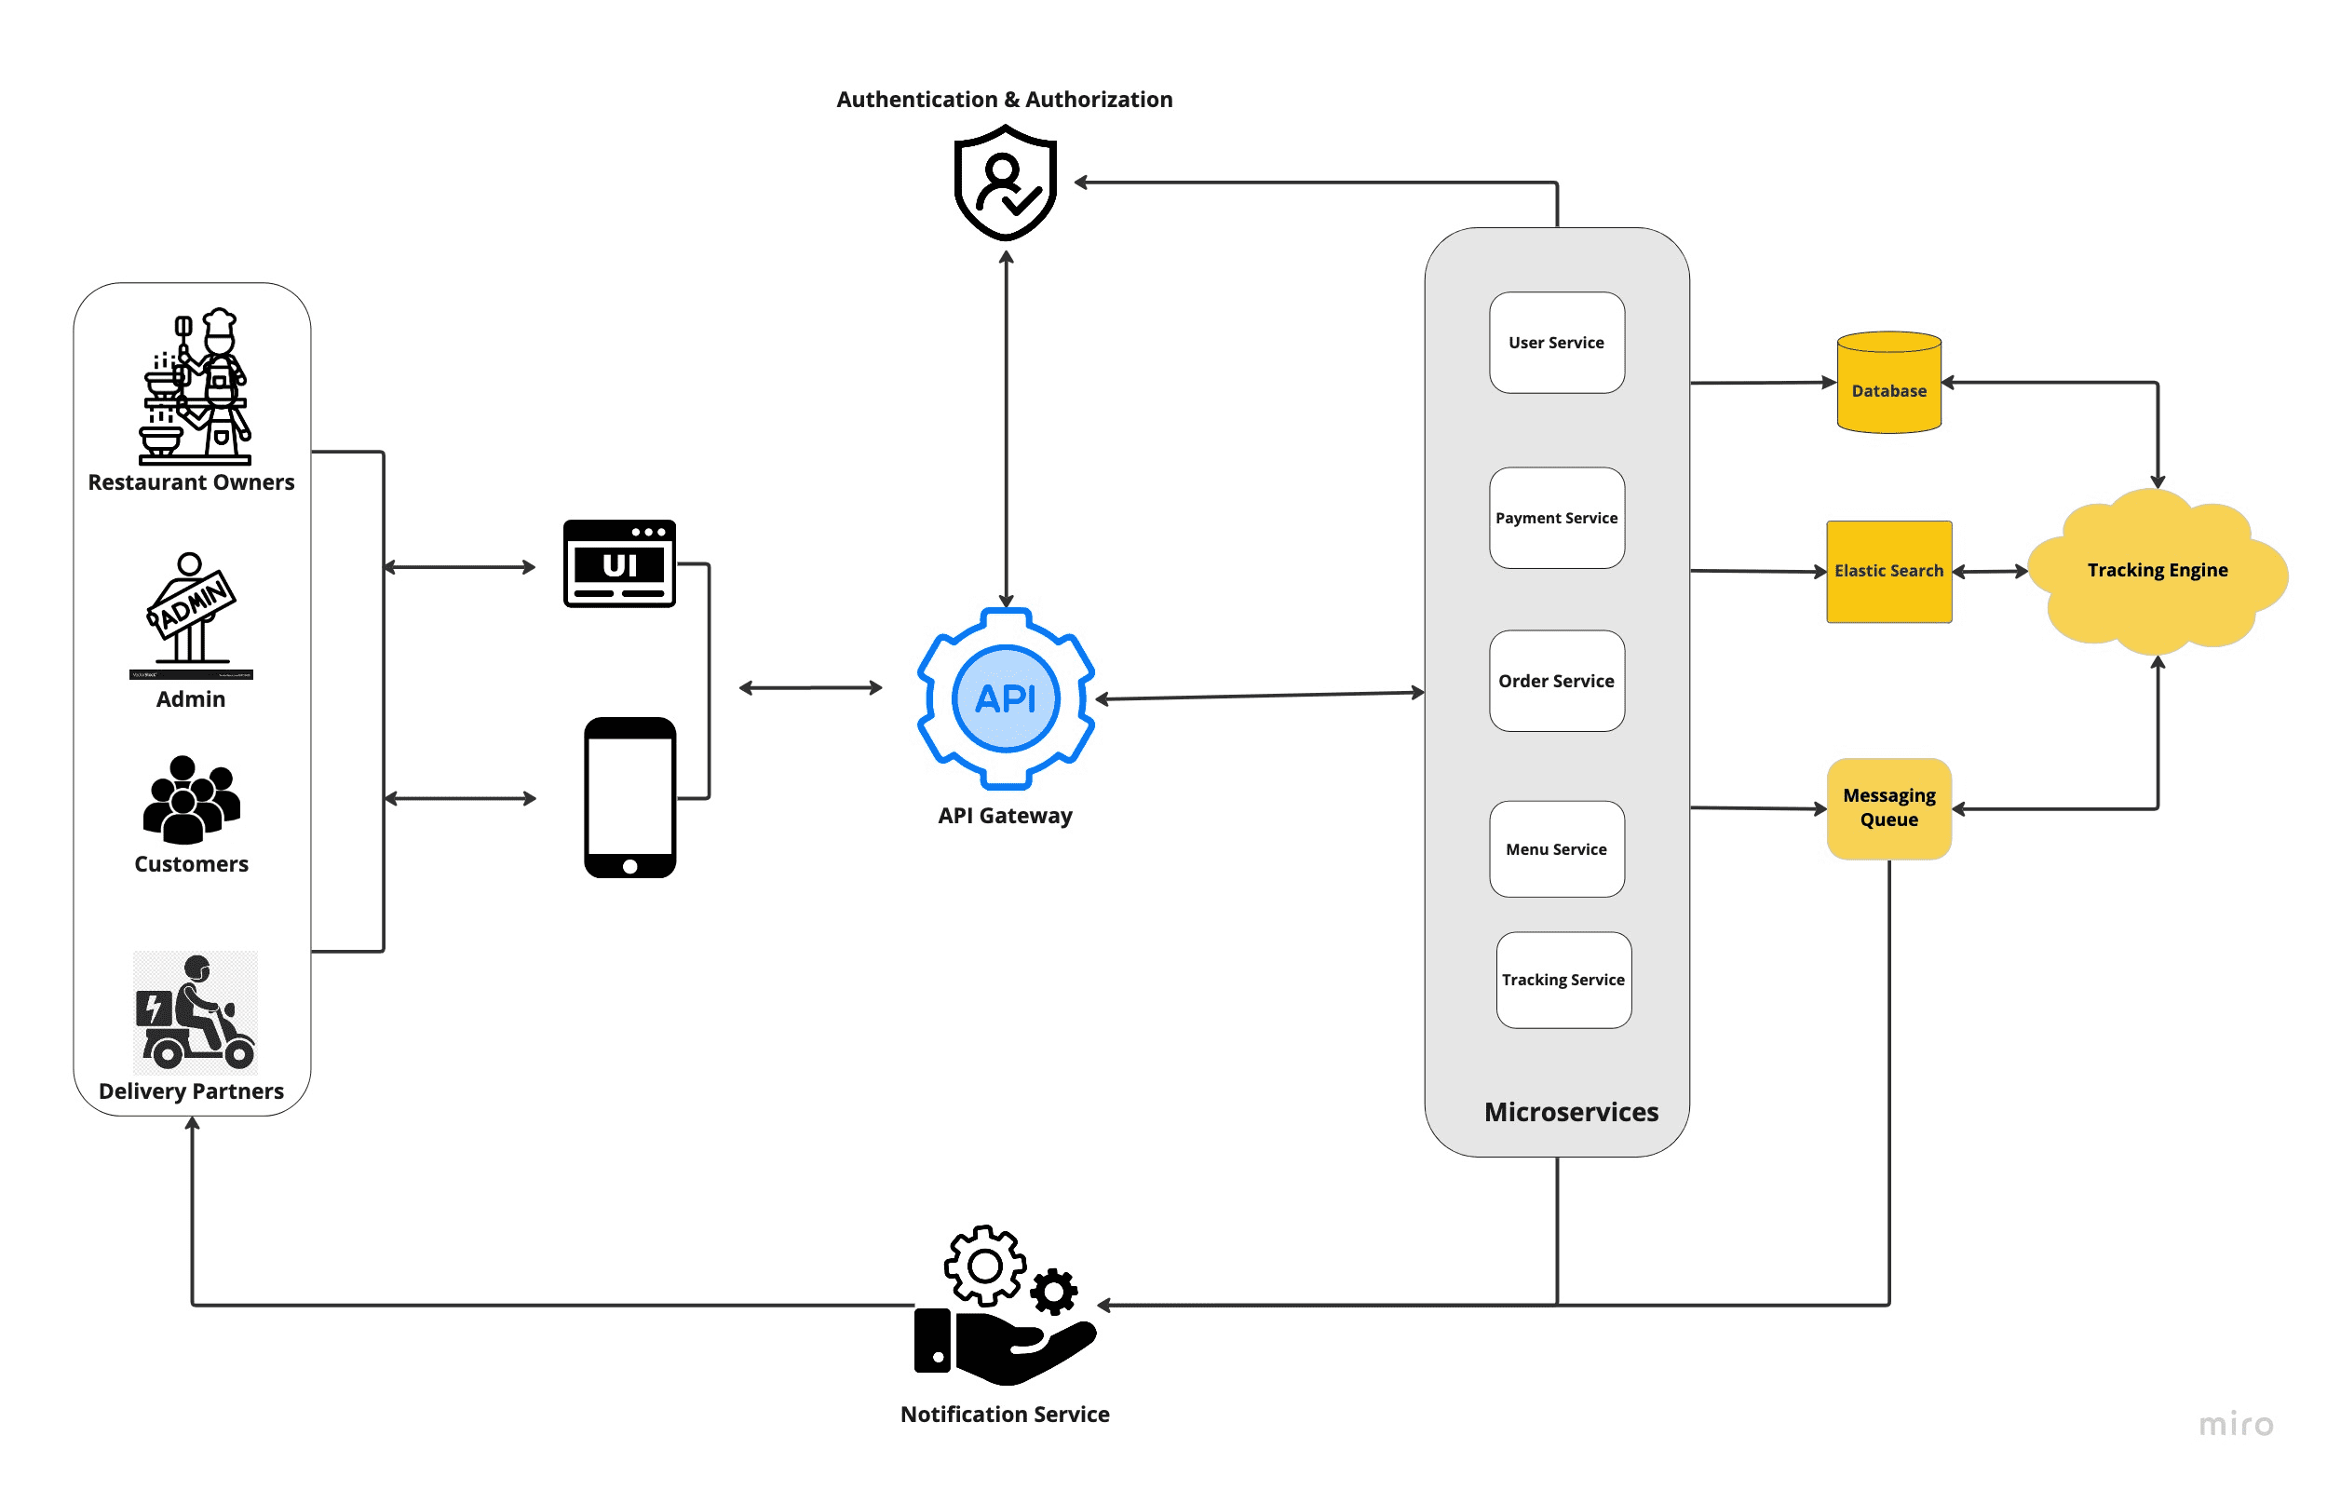
Note: You are completely free to build your own diagram. This is just a template example to give you an idea. The design can be as simple as you want as long as it depicts your project workflow and guides you and eases your way towards implementation.
- Technologies

- Programming Languages
- Java, JavaScript, Python
- Frameworks and Libraries
- Framework 1:Springboot for the backend.
- Framework 2: React for frontend.
- (Add more frameworks as necessary)
- Tools and Services
- Version Control: Git/GitHub - Used for version control, hosting the project repository, and enabling seamless team collaboration through branch management and pull requests.
- Data Management: PostgreSQL - Serves as the primary database management system to securely store, retrieve, and manage the platform's data.
- Tool/Service 2:…
- (Add more tools/services as necessary)

